**Project Design Phase-II**

**Technology Architecture**

|  |  |
| --- | --- |
| Date | 17 October 2022 |
| Team ID | B2-2M4E |
| Project Name | Skill and Job Recommender |
| Maximum Marks | 4 Marks |

**Technical Architecture:**

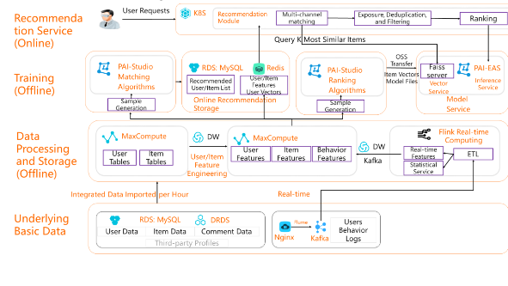

**Table-1 : Components & Technologies:**

|  |  |  |  |
| --- | --- | --- | --- |
| **S.No** | **Component** | **Description** | **Technology** |
|  | User Interface | Web UI, Mobile App, Chatbot. | HTML, CSS, Java. |
|  | Application Logic-1 | Using Flask to create a application format. | Python,HTML. |
|  | Application Logic-2 | Using Sendgrid application. | IBM Watson STT service |
|  | Application Logic-3 | Using Cloud , Docker CLI , Kubernity. | IBM Watson Assistant |
|  | Database | Data Type (Primitive & Non-Primitive ) | MySQL. |
|  | Cloud Database | Database Service on Cloud | IBM DB2, IBM Cloudant etc. |
|  | File Storage | Files are stored in Local file system. | Local File system. |
|  | External API-1 | Used to Store a Data. | IBM Weather API. |
|  | External API-2 | Verification ID of applicant. | Aadhar API. |
|  | Machine Learning Model | Using to share a data and stored. | NLP. |
|  | Infrastructure (Cloud) | Application Deployment on Local System. | Cloud Foundry ,Kubernetes. |

**Table-2: Application Characteristics:**

| **S.No** | **Characteristics** | **Description** | **Technology** |
| --- | --- | --- | --- |
| 1. | Open-Source Frameworks | To design a frame. | Lenskit. |
|  | Security Implementations | access controls implemented, use of firewalls. | Encryptions, OWASP. |
|  | Scalable Architecture | Potential to implement more advance features of the application. | Cloud. |
|  | Availability | use of distributed servers etc. | Twilio sendgrid. |
|  | Performance | Design consideration for the performance of the application number of requests per sec, use of Cache, use of CDN’s . | PTP. |